
PT1/IPCQP/1223/A 08-MAY-2023
PERIODIC TEST - I (2022-23)
Subject: Informatics Practices(c)  Grade: XII |  | Max. Marks: 35  Time: 1 Hr 20 Mins
 | SECTION A |  | (9)
1. | Ravisha has stored the records of all students of her class in a MYSQL table. Suggest a suitable SQL clause that she should use to display the names of students in alphabetical order. |  | 1
 | - SORT BY
 | - ALIGN BY
 | - GROUP BY
 | - ORDER BY
2. | To remove the leading and trailing space from data values in a column of MySql Table, we use |  | 1
 | - Left
 | - Right()
 | - Trim()
 | - Ltrim()
3. | If the substring is not present in a string, the INSTR() returns:  - -1  - 1  - NULL  - 0 |  | 1
4. | Which of the following is not a valid aggregate function in MYSQL? |  | 1
 | - COUNT()
 | - SUM()
 | - MAX()
 | - LEN()
5. | Which function accepts a character string as an input and provides character string or numeric  values as an output? |  | 1
 | - Text
 | - Time
 | - date
 | - math
6. | Identify single-row functions of MySQL amongst the following.  - TRIM()  - MAX()  - ROUND()  - (d) Both (a) and (c) |  | 1
7. | Predict the output of the following query:  SELECT MOD (9,0); |  | 1
 | - 0
 | - NULL
 | - NaN
 | - 9
8. | Complete the query select _______('2023-05-11')+1; so that it returns 6  - Date  - Month  - Year  - Dayofweek |  | 1
9. | _________________ is used to delete existing records in a table.  - REMOVE  - DELETE  - DROP  - CLEAR |  | 1
 | SECTION B |  | (12)
1. | State the purpose of the following functions with example:  - Mid()  - mod () |  | 2
2. | Differentiate between COUNT () and COUNT (*) functions in MYSQL. Give suitable examples to support your answer. |  | 2
3. | Aryan, a database administrator, has grouped records of a table with the help of group by clause.He needs to further filter groups of records generated through group by clause.  Suggest suitable clause for it and properly explain its usage with the help of an example. |  | 2
4. | Create a table INVENTORY with the given structure:  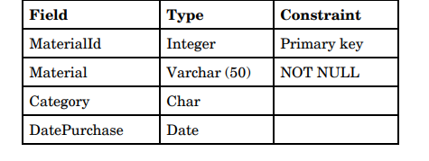 |  | 3
5 | Find the output of the following SQL queries:  (i) SELECT SUBSTR(“CLIMATE CHANGE”, 4,4)  (ii) SELECT UCASE(RIGHT (“Pollution” , 3))  (iii) SELECT LENGTH (“HAPPY”)+3; |  | 3
 | SECTION C |  | (14)
1 | Write SQL queries for the following:  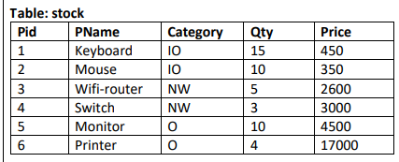  (a) To display the records in decreasing order of price.  (b) To display category and category wise total quantities of products.  (c) To display the category and its average price.  (d) To display category and category wise highest price of the products. |  | 4
2. | Consider the table STUDENT given below, write MySQL Commands for (i) to (v).  Table: Student  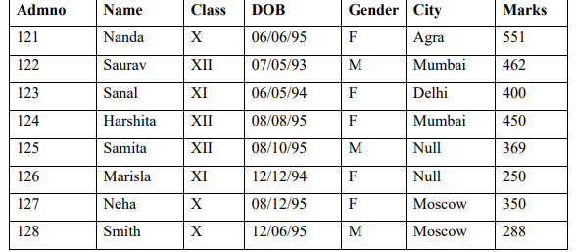  i. To display name and marks. (Note: Marks should be shown as increased value by 10  i.e marks+10).  ii. To display students records whose name starts with 'N' alphabet.  iii. To display all the information of females whose city is NEITHER Delhi nor Mumbai.  iv. To display the details of all the students whose date of birth is after Nishant’s Birth date  12/6/95.  v. To display admno and Gender of those students whose city is not known. |  | 5
3. | Write the SQL queries which will perform the following operations  - To display the year from your Date of Admission which is 2023-05-15.  - To convert your email id ‘ABC@XYZ.com’ to lowercase.  - To remove leading spaces from a string ‘my country’.  - To display current date.  - To display the value of 10⁶. |  | 5
***

